For more information,

or answers to questions regarding

Calvary Church Outreach Ministries,

please contact:

Bethany Thomas

Pastor for Community Connection and Outreach

Office: 303-279-2188

Cell: 303-808-7816

Email: [bethany@calvarygolden.net](mailto:deacon.bethany@calvarygolden.net)

OUTREACH

MINISTRY

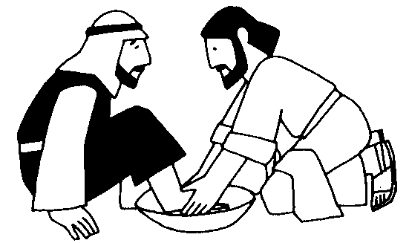  
  
  
 october  
 2018

opportunities to  
 give, serve and participate…

C:\Documents and Settings\BThomas\Local Settings\Temporary Internet Files\Content.IE5\OIGZP1N8\MC900388770[1].wmf  
**CALVARY FOOD SHELF**  
Item of the month:   
 **GRANOLA BARS**

MCj02810680000[1]**is your BP rising?**  
 **October 14, 10:15-11:15 am**   
Blood pressure checks will done in the office area of the Ministry Center.

 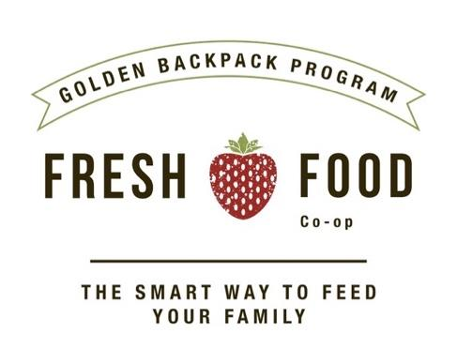

**Golden Backpack program…Fresh Food co-op**

**Immediate need for volunteers:  
 Mondays and Wednesdays, 10:30 am - 12:30 pm**

**Located inside New Hope Community Church  
 16800 W. 9th Ave.Golden, CO 80401 *(2 blocks east on 9th off of Ulysses)***

The Golden Backpack Program, that works to feed hungry kids in our community, is in desperate need of volunteers to help at their Fresh Food Co-op, located at New Hope Community Church. They are especially looking for help with the food deliveries that come on Mondays and Wednesdays, 10:30-12:30. To help, please go to the website and sign-up to volunteer.   
 [www.goldenbackpack.org](http://www.goldenbackpack.org)   
  
 Contact: Bethany Thomas, [bethany@calvarygolden.net](mailto:bethany@calvarygolden.net) or 303-808-7816  
  


**October 14, 8 am – Noon, Bell Middle School**   
Mark your calendar to participate in the upcoming 9Health Fair right here in our community. For information on costs, screenings, volunteer opportunities or to pre-register on the Golden site go to:  
 <https://www.9healthfair.org/health-fairs/fall/4/index>

[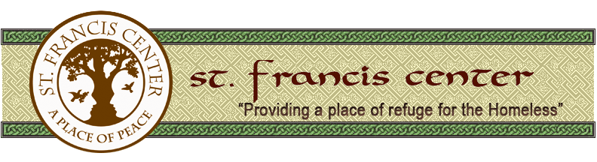](http://www.sfcdenver.org/index.html)  
**St. francis center Sunday**

**October 28, 8 am-Noon**  
Calvary volunteers are needed to serve at this day shelter for the homeless in Denver. Activities include helping in the clothing room,  
the laundry or at the mail and storage desk.  
 Contacts: Kate Felix, [kgfelix@mail.com](mailto:kgfelix@mail.com)   
 Kathie Gerwig, [kdgedg2@gmail.com](mailto:kdgedg2@gmail.com)

**MCj04136860000[1] Thanksgiving dinners…  
$25 donations and volunteers needed** **Donations collected October 13 - November 11  
 Distribution on Saturday, November 17**Monetary donations are needed to help purchase food for individuals and families in Golden who would otherwise not have a Thanksgiving holiday meal. Be sure to watch for the displays in the Great Hall lobby and the Parish Hall, or bring your check or cash to the office during the week, starting October 13th. Volunteers to help with distribution are also needed on Saturday, 11/17. More details to follow!  
 Contacts: Bethany Thomas, 303-279-2188  
 Shannon Campbell, 303-588-5926